**Circuit and System-I Lab**

**LAB # 12**



**Spring 2022**

Submitted by: Ali Asghar

Registration No.: **21PWCSE2059**

Class Section: **C**

“On my honor, as student of University of Engineering and Technology, I have neither given nor received unauthorized assistance on this academic work.”

Student Signature: ______________

Submitted to:

**Engr. Faiz Ullah**

4 July, 2022

Department of Computer Systems Engineering

**ASSESSMENT RUBRICS LAB # 12**

**Complex Circuit Analysis using MATLAB**

|  |  |  |  |  |
| --- | --- | --- | --- | --- |
| **LAB REPORT ASSESSMENT** | | | | |
| **Criteria** | **Excellent** | **Average** | **Nill** | **Marks Obtained** |
| 1. **Objectives of Lab** | All objectives of lab are properly covered  [Marks 0.5] | Objectives of lab are partially covered  [Marks 0.25] | Objectives of lab are not shown  [Marks 0] |  |
| 1. **Complex Circuit**   **(Theory, Circuit Diagram )** | Brief introduction about Complex Circuit (How to apply KVL equations in each mesh) is shown along with properly labeled circuit diagram  [Marks 2] | Some of the points about Mesh Current Analysis are missing and circuit diagram is not properly labeled  [Marks 0.5] | Introduction about complex circuit and circuit diagram is not shown  [Marks 0] |  |
| 1. **MATLAB** | Brief introduction of MATLAB  [Marks 1] | Brief introduction of MATLAB  Is not shown  [Marks 0] | |  |
| 1. **MATLAB code** | All experimental code of MATLAB is shown  [Marks 3] | Some of the codes are missing  [Marks 1.5] | Full codes are missing  [Marks 0] |  |
| 1. **Comparisons of MATLAB and PSpice** | Results are verified  [Marks 2.5] | Results are not verified  [Marks 0] | |  |
| 1. **Conclusion** | Conclusion about experiment is shown  [Marks 1] | Conclusion about experiment is partially shown  [Marks 0.5] | Conclusion about experiment is not shown  [Marks 0] |  |
| Total Marks Obtained:__________  Instructor Signature: ______________________ | | | | |

**TITLE:**

**Complex Circuit Analysis using MATLAB**

**OBJECTIVES:**

* + - * To know about complex circuits
      * To know the basic interface of MATLAB & it’s uses
      * To analyze given circuit using MATLAB
      * To be able to use MATLAB for mathematical calculations
      * To draw a Complex Circuit using PSPICE

**APPARATUS:**

* Computer with PSPICE and MATLAB software installed on it

**COMPLEX Circuit:**

A complex circuit configuration is one that contains components that neither a parallel nor series with each other. If a circuit can be reduced to a single resistor, it is a series or parallel.

**MAIN FEATURES:**

* Complex circuits cannot be reduced to a single resister and contain components that are neither a series nor a parallel.
* Resistors are connected in a complicated manner.
* Complex circuits contain more than one source of electromotive force or pure voltage source.
* They cannot be solved by using series and parallel combinations.

**Example:**

Following is the example of complex circuit

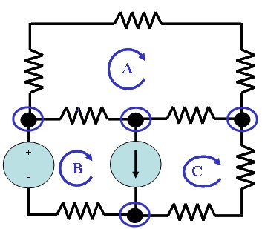

# Kirchhoff’s Voltage Law:

Kirchhoff’s Voltage Law states that in any closed loop circuit the total voltage will always equal the sum of all the voltage drops within the loop.

**Steps of APPLYING KVL ON MESHES:**

Following are the main steps involved

1. Identify the number of basic meshes.
2. Assign a current to each mesh.
3. Then apply Kirchhoff’s Voltage Law (KVL) in order to get an equation in terms of loop current.
4. Then solve the system of equation(s) obtained as a result of the KVL.

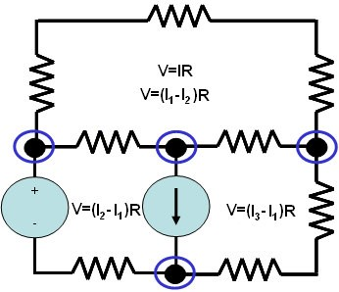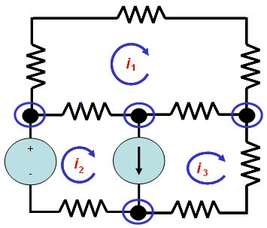

Step 1 Step 2 Step 3

**MATLAB:**

MATLAB is a high-performance language for technical computing. It integrates computation, visualization, and programming in an easy-to-use environment where problems and solutions are expressed in familiar mathematical notation. Typical uses include:

* Math and computation
* Algorithm development
* Scientific and engineering graphics
* Application development, including Graphical User Interface building

**GIVEN COMPLEX CIRCUIT:**

Following complex circuit will be solved using my registration number in resistor values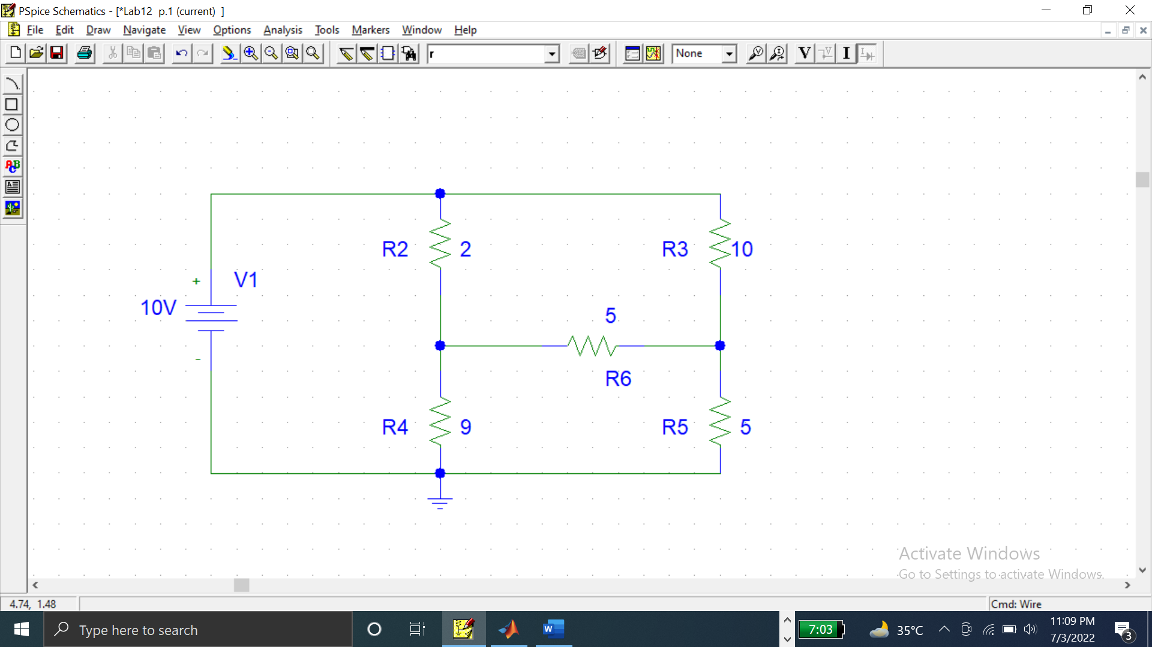

**SOLVING COMPLEX CIRCUIT:**

Consider three meshes containing current I1,I2 and I3. Let’s suppose I1 is flowing in mesh 1, I2 in mesh 2 and I3 in mesh 3.

Now the mesh current analysis for mesh 1 , 2 and 3 is:

**FOR MESH 1:**

**FOR MESH 2:**

**FOR MESH 3:**

**MATRIX FORM:**

The Above simplified equations can be written as in matrix form:

**MATLAB CODE:**

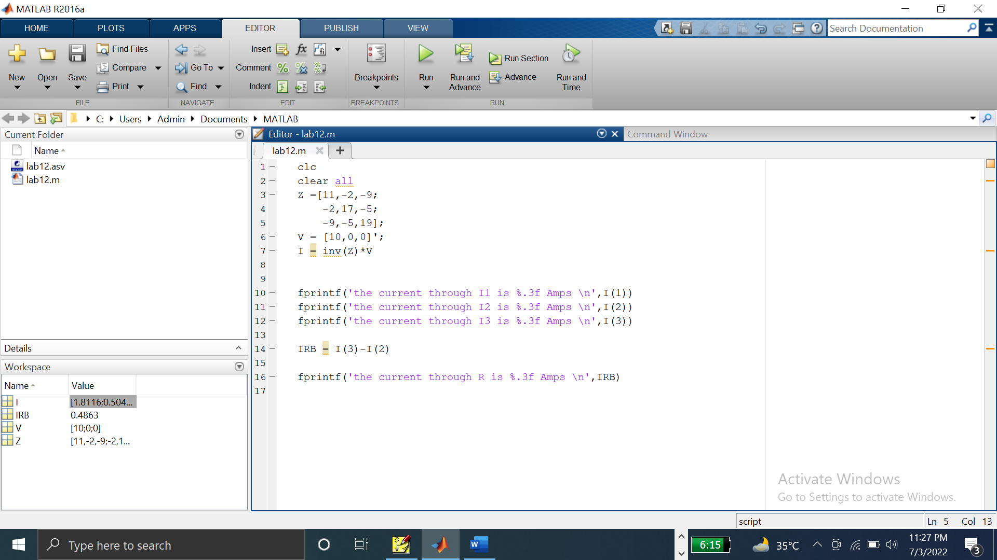

**STEPS:**

1. First of All,We introduce symbol sign to tell compiler that we have to find them like I1, I2 etc.
2. Then introduce a variable and put all the values of matrix in it what it be of 2 x 3,or 3x3. E.g A=[1 2 3 ;4 5 6;7 8 9]
3. Take another variable I and put all values we have to find.

I= [I1,I2,I3]

1. Take matrix third values and give it another name like B=[1;2;3]
2. Now use formula to find value and execute program.
3. Repeat the same procedure for different circuits and equations.

**MATLAB Command window output:**

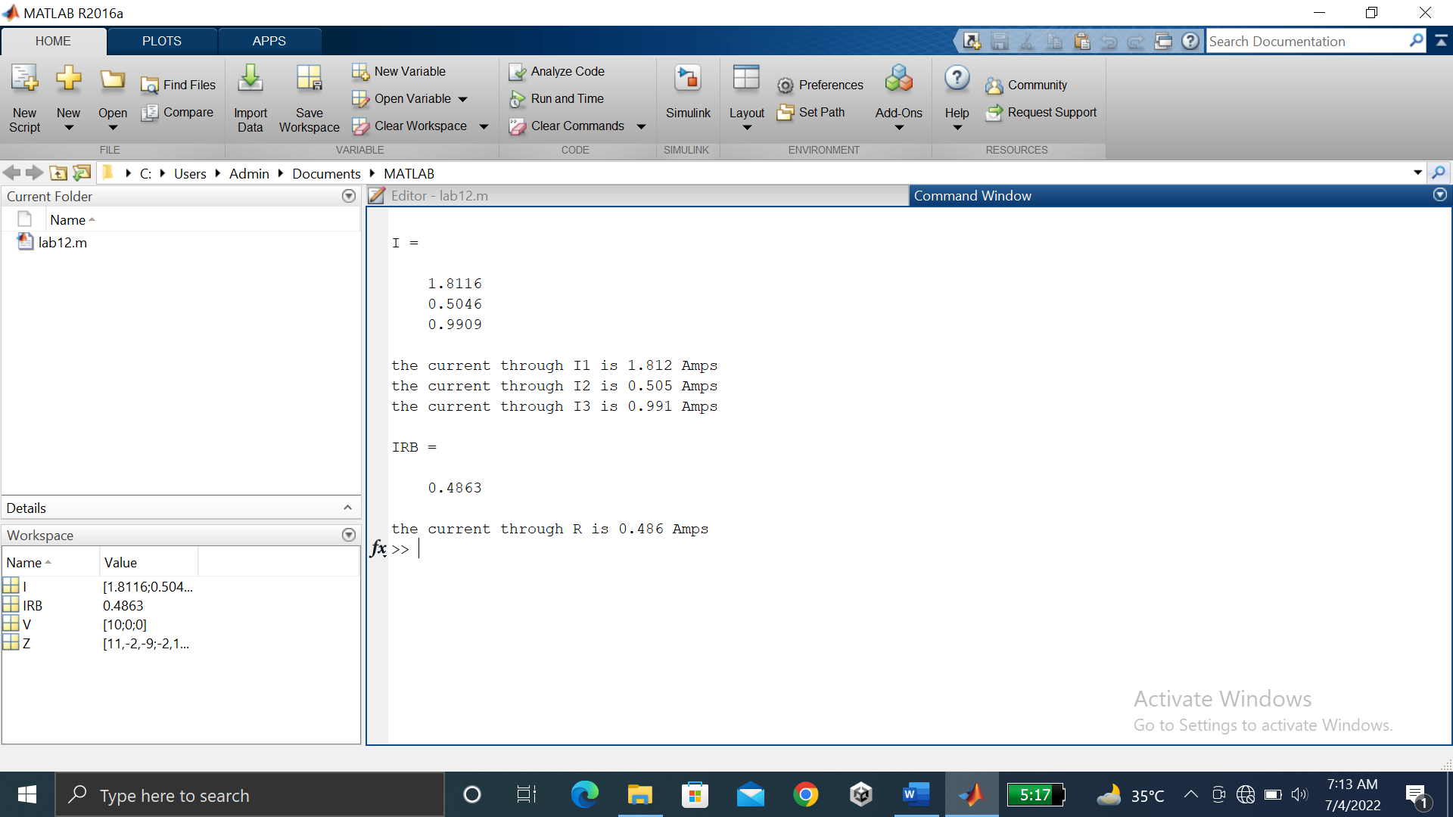

**COMPLEX Circuit CURRENT VERIFICATION IN PSPICE:**

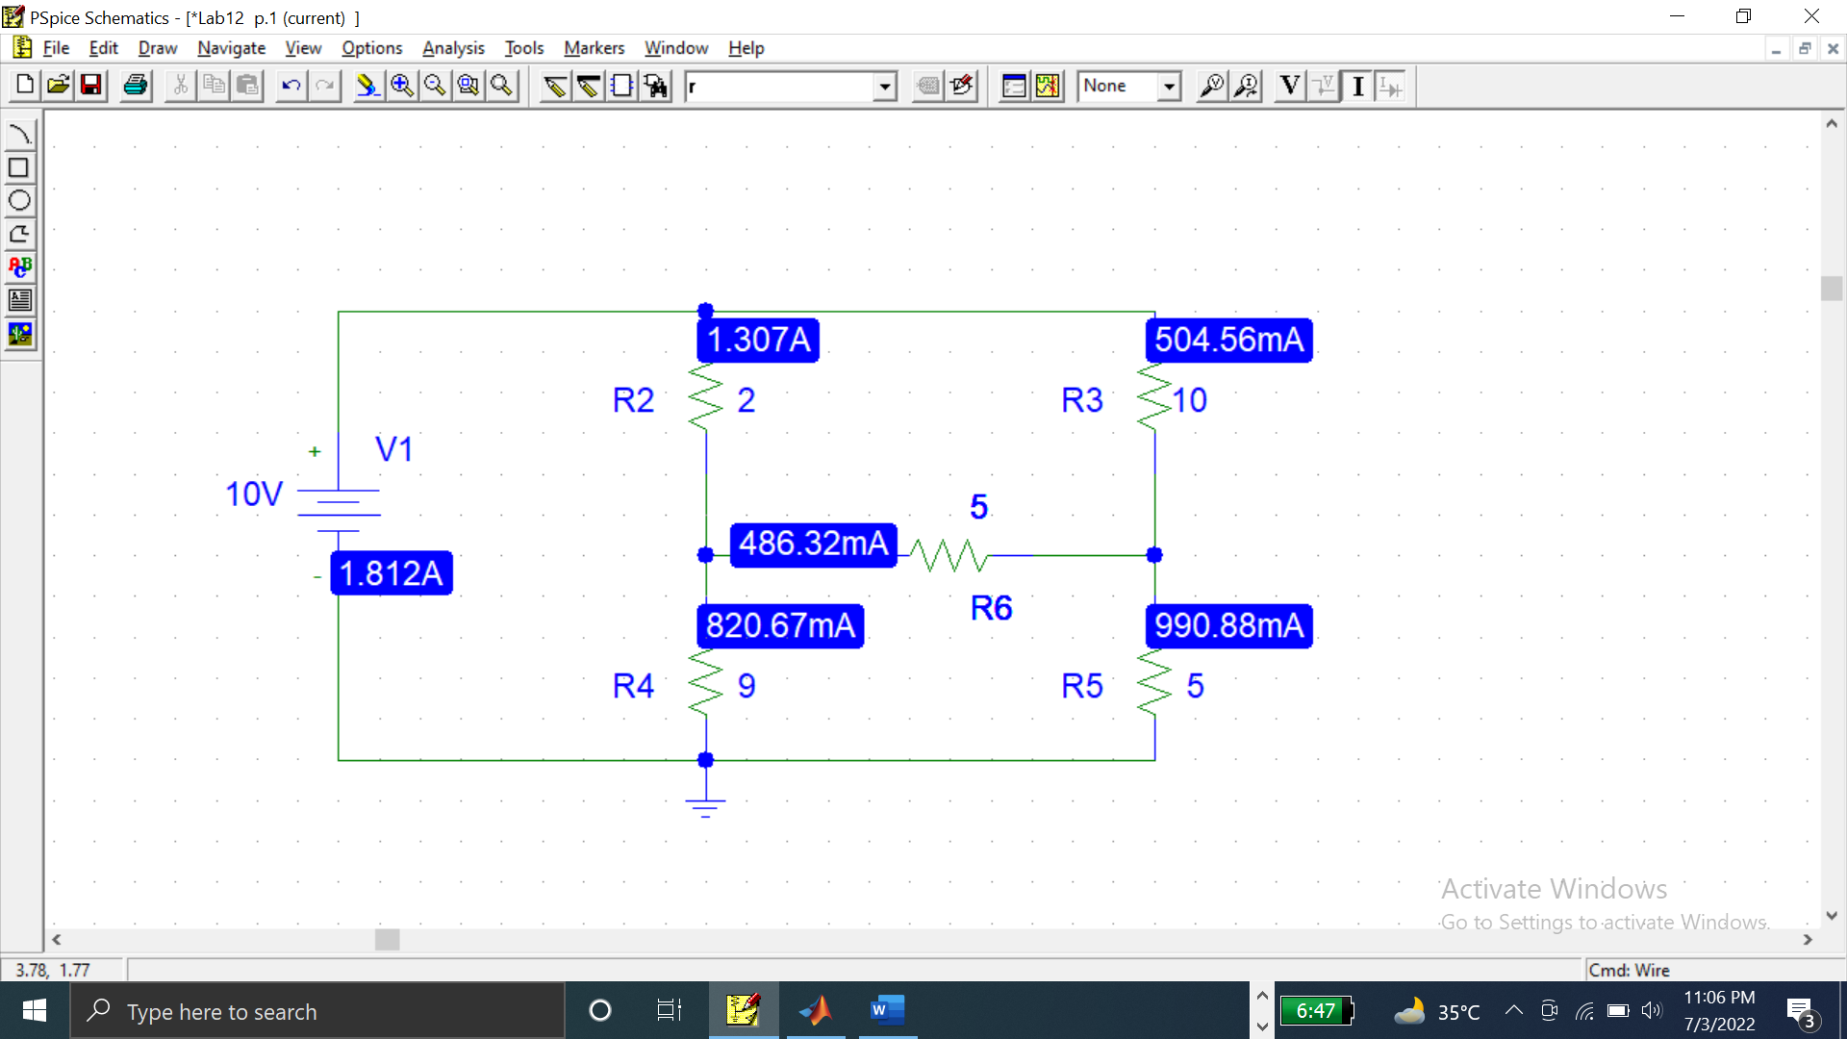

**OBSERVATIONS AND RESULTS:**

Following results are verified with the help of PSCPICE

|  |  |  |  |  |
| --- | --- | --- | --- | --- |
| S. NO. | MATLAB RESULTS | | PSPICE RESULTS | |
| 1 | I1 | 1.812A | I1 | 1.812A |
| 2 | I2 | 0.505A | I2 | 504.56mA |
| 3 | I3 | 0.991A | I3 | 990.88mA |
| 4 | IRB | 0.4863A | IRB | 486.32mA |

**CONCLUSION:**

From this experiment, we concluded that MATLAB can be used as a powerful tool for performing mathematical operations such as solving 3x3 matrix in this case. Apart from this, MATLAB also has applications in Image and signals processing.